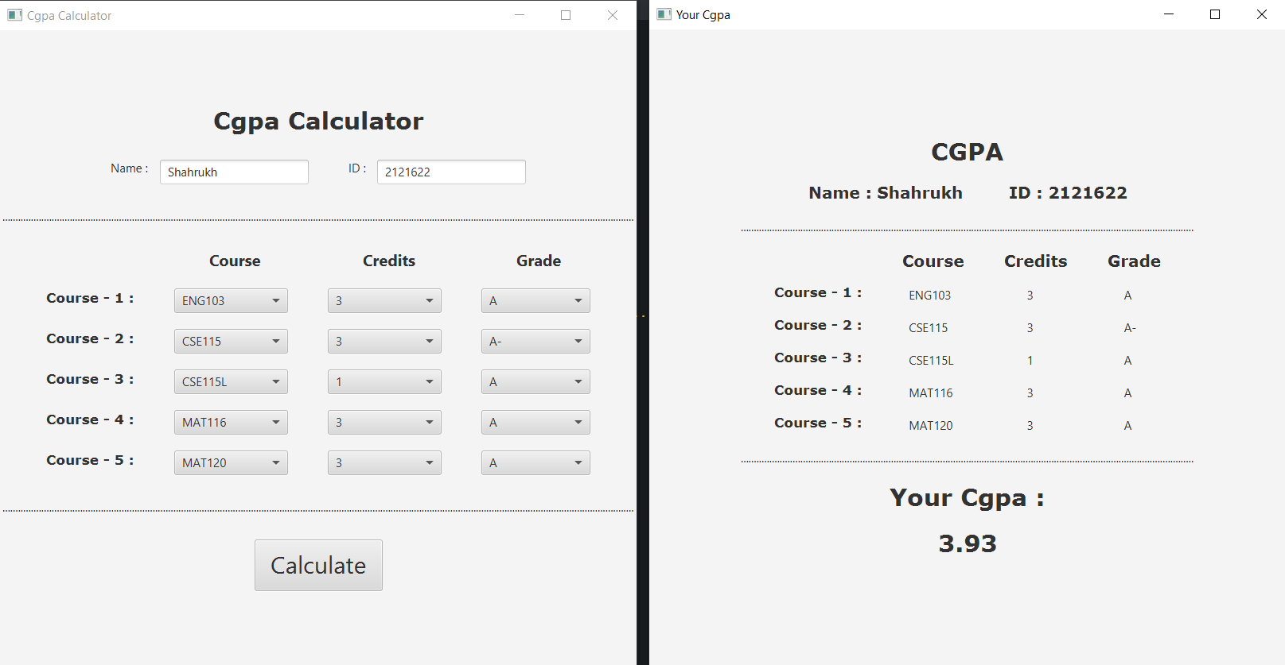

CGPA CALCULATOR

this calculator can calculate the cgpa of 5 courses.

SHAHRUKH KHAN | CSE215L |10/5/2022

Abstract : CGPA calculator is a simple project which is developed to calculate the CGPA of courses. This calculator can calculate the cgpa upto 5 courses by taking the courses, credits and grades as input and shows the calculated cgpa as output.

Environment :

* JDK 1.8
* Eclipse
* JavaFx

Methodology :

This project consists of 2 classes. One is the driver class which is named as ‘Main’ and another is for the methods which is named as ‘Methods’.

In the Main class, at first, An object for the Methods class named as ‘obj’ has been created . Then, An UI was created by declaring all the necessary Classes. The ‘Label’ class was used to write something in our project. The font, font-weight, font-size of the label has been set by using the ‘setFont’ according to our necessity. The ‘TextField’ is used to create a text field which takes a text as input. HBox and VBox was used to create horizontal row and vertical column respectively. To align the items horizontally and vertically the HBox and VBox were used. The ‘setAlignment’ method was used to horizontally and vertically place the items to the center. Diagram 1 illustrates the title along with the textfield’s of name and id.

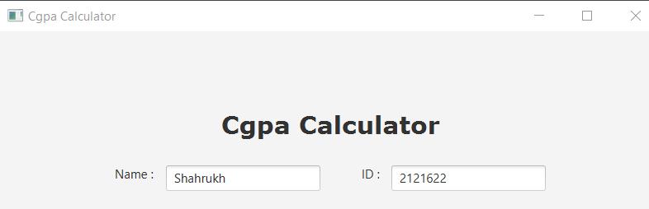

Diagram 1 : cgpa Calculator

Here, 3 ComboBox for a row was created. The first ComboBox is for the course, second is for the credits and the last one is for the grades. After creating the first Combobox , the Combobox was sent as argument in the object named as ‘obj’ which was created earlier and used the ‘Courses’ method to add the necessary courses. Likewise, the second and third Combobox was sent as argument in the ‘obj’ to set the ‘Credits’ and ‘Grades’ respectively. Similarly, this process was repeated 4 more times to create a total of 5 rows of Comboboxes. Then, the HBox and VBox was used to horizontally and vertically align the items. Diagram 2 shows the information about the courses which are to be calculated and upon clicking on the field a dropdown menu will open.

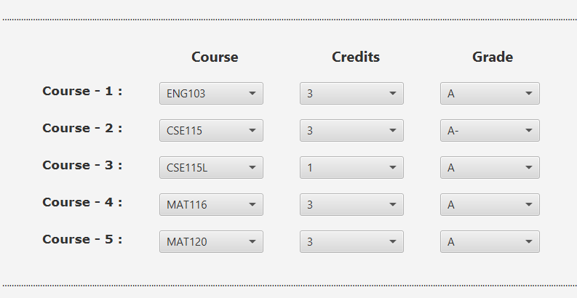

Diagram 2: Course Details

After adding all the necessary items, the ‘Button’ class was used to create an object of it. This object was used to create a button. The ‘setFont’ method was used to set the size of the button. The ‘setOnAction’ method was used to define what the button will do after clicking on it. The ‘SelectedItems’ of the Methods class was used to get the items of the combobox selected by the user. The inputs of the textfield was taken as text and pass it on the ‘Display’ method as argument along with the Comboboxes to create a new window which shows a different UI along with the calculated CGPA. Then the HBox and VBox was used to align the items. The diagram 3 below illustrates the calculate button, upon clicking on it cgpa will be calculated and show the output on a new window.

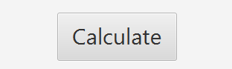

Diagram 3: Calculate Button

Lastly, all the HBox was put in a VBox . An object of the ‘Scene’ class was created and passed that VBox as the argument along with the height and width of the window which will be created. Finally, An object of the ‘Stage’ class was created and the scene was passed as the argument. The title of the stage was set by using ‘setTitle’. The ’show()’ method was used to finally see the UI we created. Diagram 4 illustrates the full view of the CGPA Calculator.

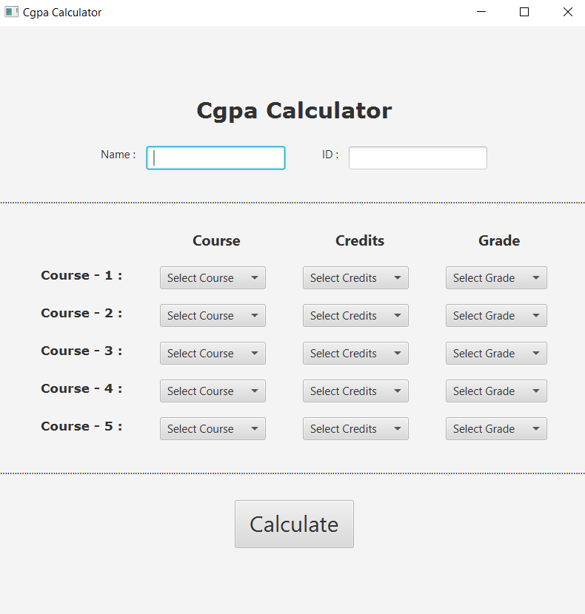

Diagram 4: Full View of Cgpa Calculator

The Methods class contains the following methods/functions :

Courses :This method takes a Combobox as a parameter. It sets the prompt text as “Select Course”. It also adds the name of each course to the Combobox which was taken as the parameter. The ‘getItems’ method was used to add items to this list. The diagram below shows the courses that are added on the list.

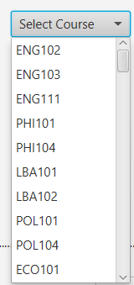

Diagram 5: Select Course Dropdown Menu

Credits : This method also takes a Combobox as a parameter. It sets the prompt text as “Select Credits”. It also adds the credits of each course to the Combobox which was taken as the parameter. The ‘getItems’ method was used to add items to this list. The diagram below shows the credits that are added on the list.

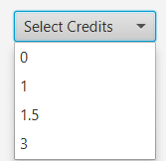

Diagram 5: Select Credits Dropdown Menu

Grades : This method takes a Combobox as a parameter. It sets the prompt text as “Select Grade”. It adds the grades of each course to the Combobox which was taken as the parameter. The ‘getItems’ method was used to add items to this list. The diagram below shows the credits that are added on the list.

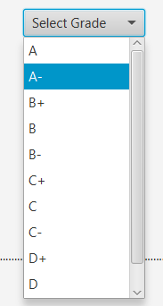

Diagram 6: Select Grades Dropdown Menu

SelectedItems : This method takes all the Combobox as a parameter. It creates a file named “Info.txt”. It writes all the selected items of the Combobox in the text file which was created earlier. The diagram below shows the courses that were selected and were written in a text file.

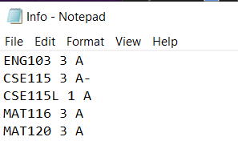

Diagram 7: Selected Items

Display : This method takes the name, id and Combobox of credits and grades. Here at first, the total credits selected by the user is calculated. Then all the grade point equivalent to the grade selected by the user is calculated. Thus, by dividing the total credits with the selected grade point, the Cgpa is calculated. After this, an UI like before were creared in the same way to show the output to the user. This UI was created declaring the same classes as before.

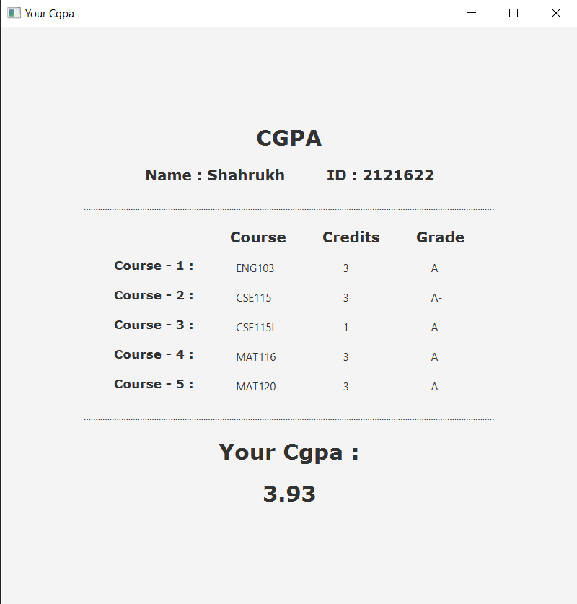

Diagram 8: Output after clicking the calculate button

Conclusion : This calculator was usually designed to calculate the cgpa of 5 courses. If needed, many more courses can be added to calculate the cgpa of it. However, this calculator works perfectly to calculate the cgpa of any number of courses.